Step:1 download hibernate jar files

Link: https://jar-download.com/artifacts/org.hibernate/hibernate-core

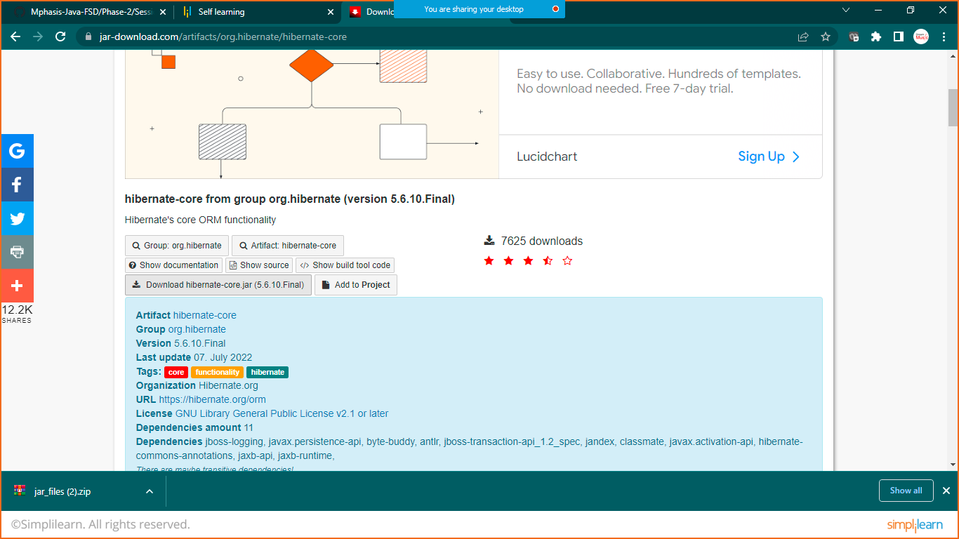

Step:2 Extract Jar File to the folder

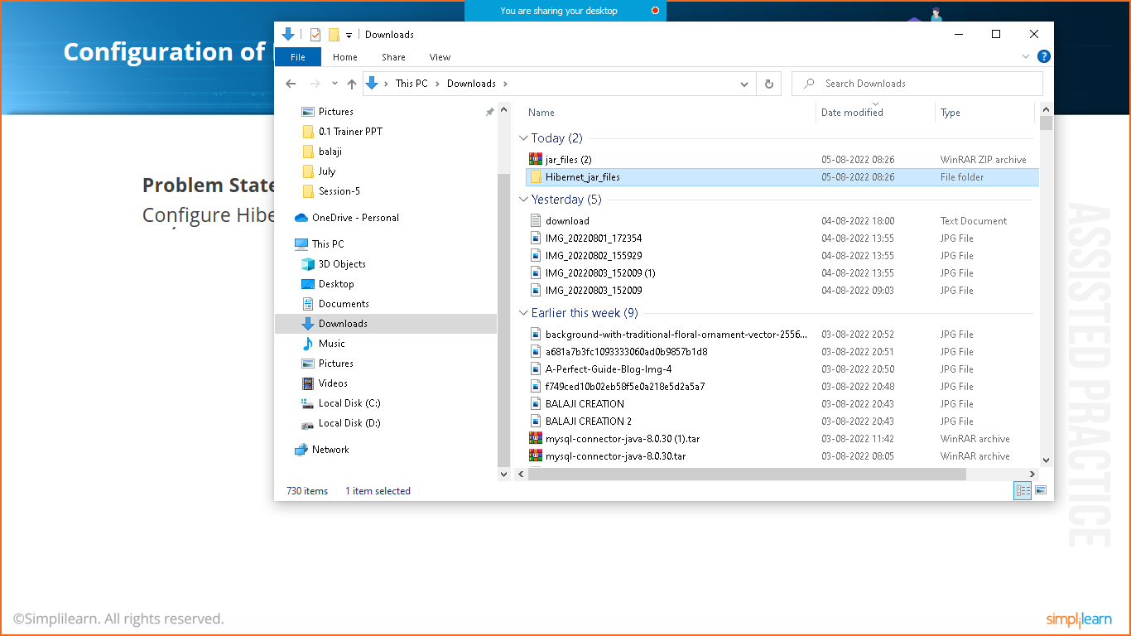

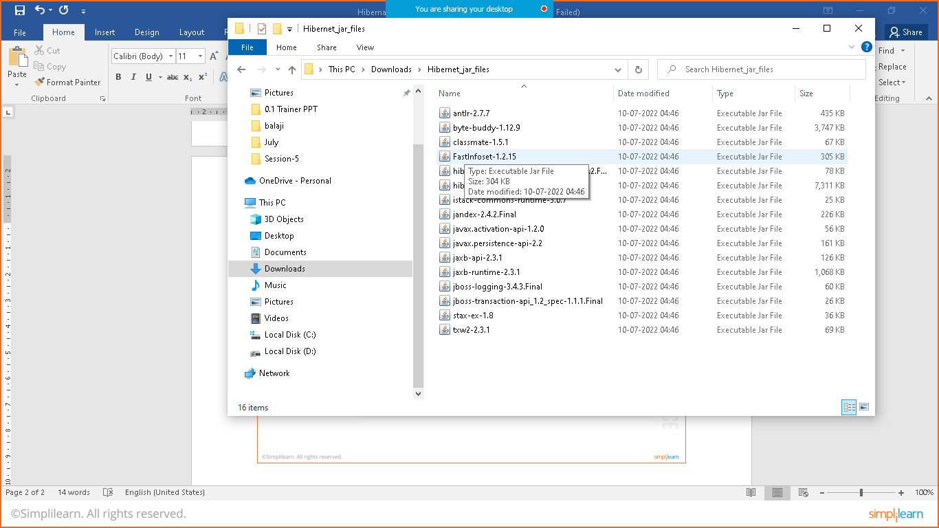

STEP3: DOWNLOAD MY SQL CONNECTOR

LINK: <https://dev.mysql.com/downloads/connector/j/?os=26>

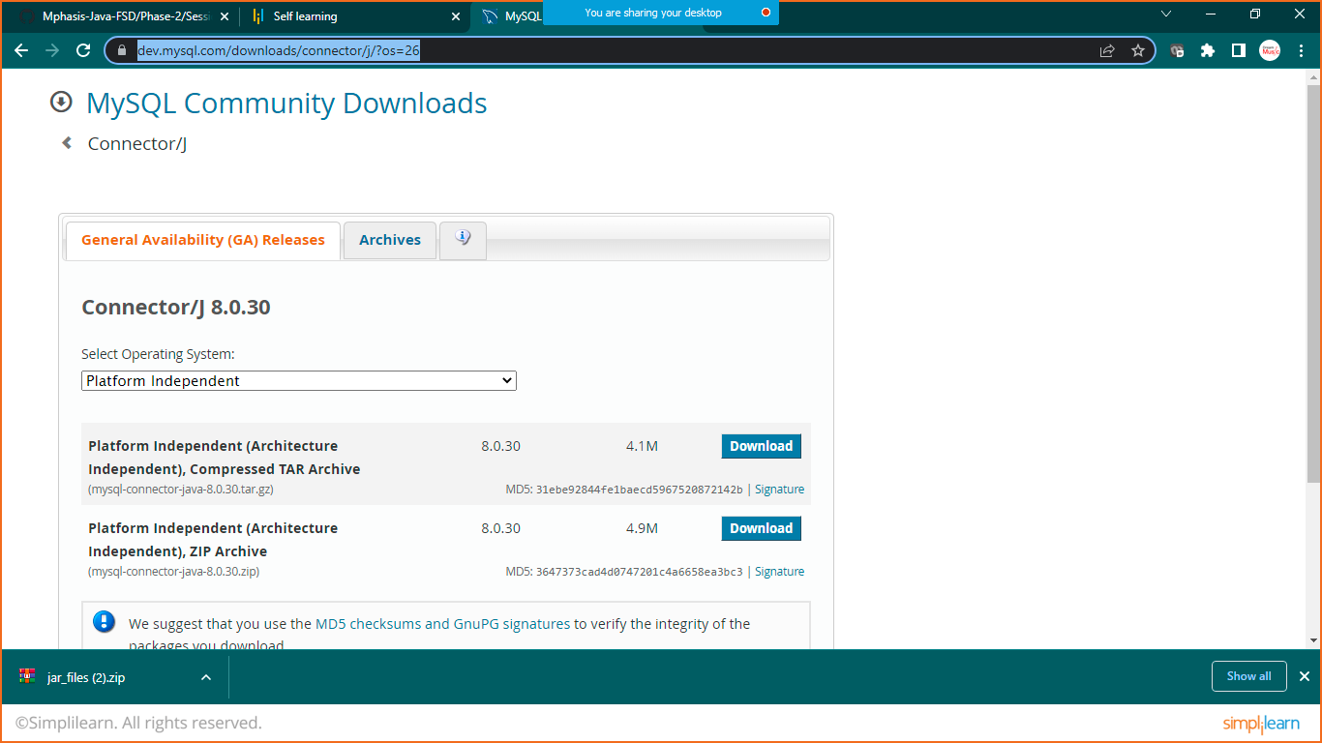

STEP: 4 extract the mysql connector

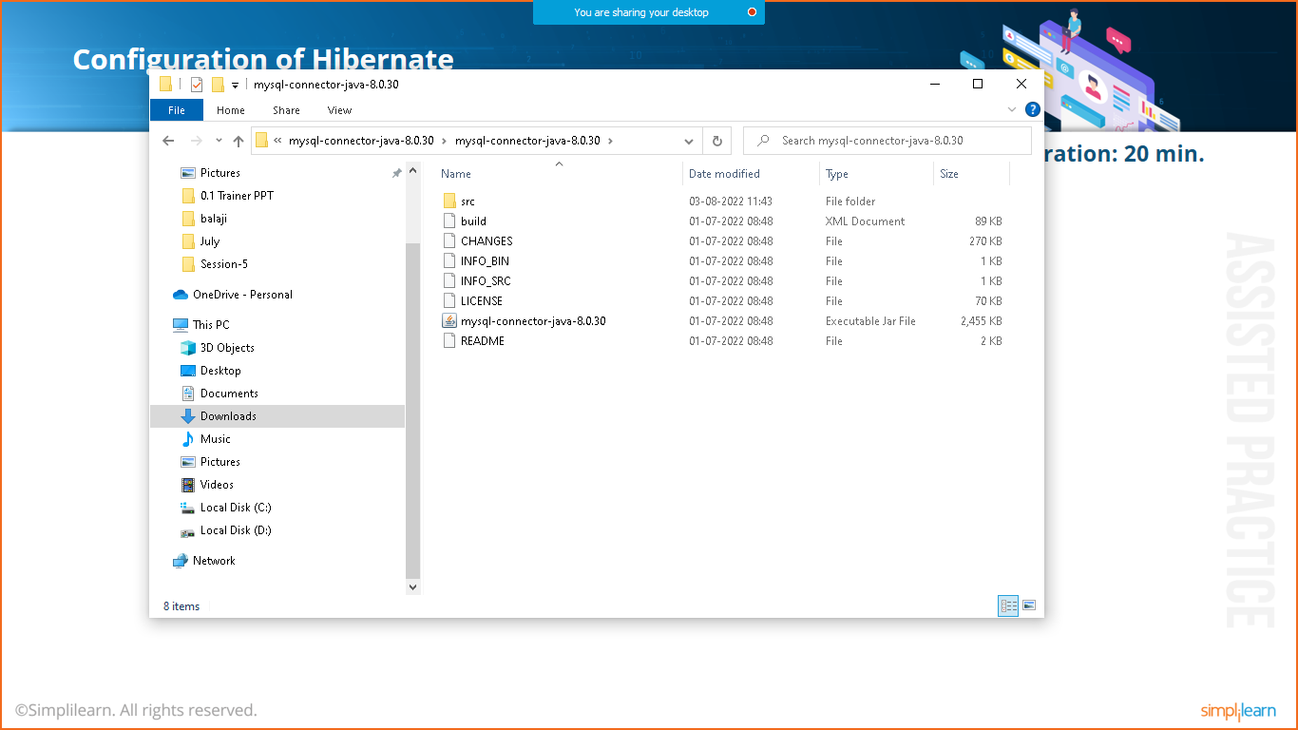

STEP 5: CREATE SIMPLE JAVA PROJECT

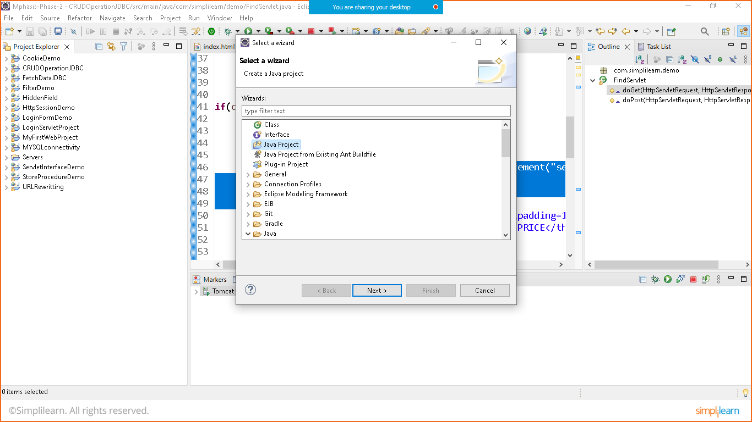

GIVE THE NAME: HibernateFirstProject

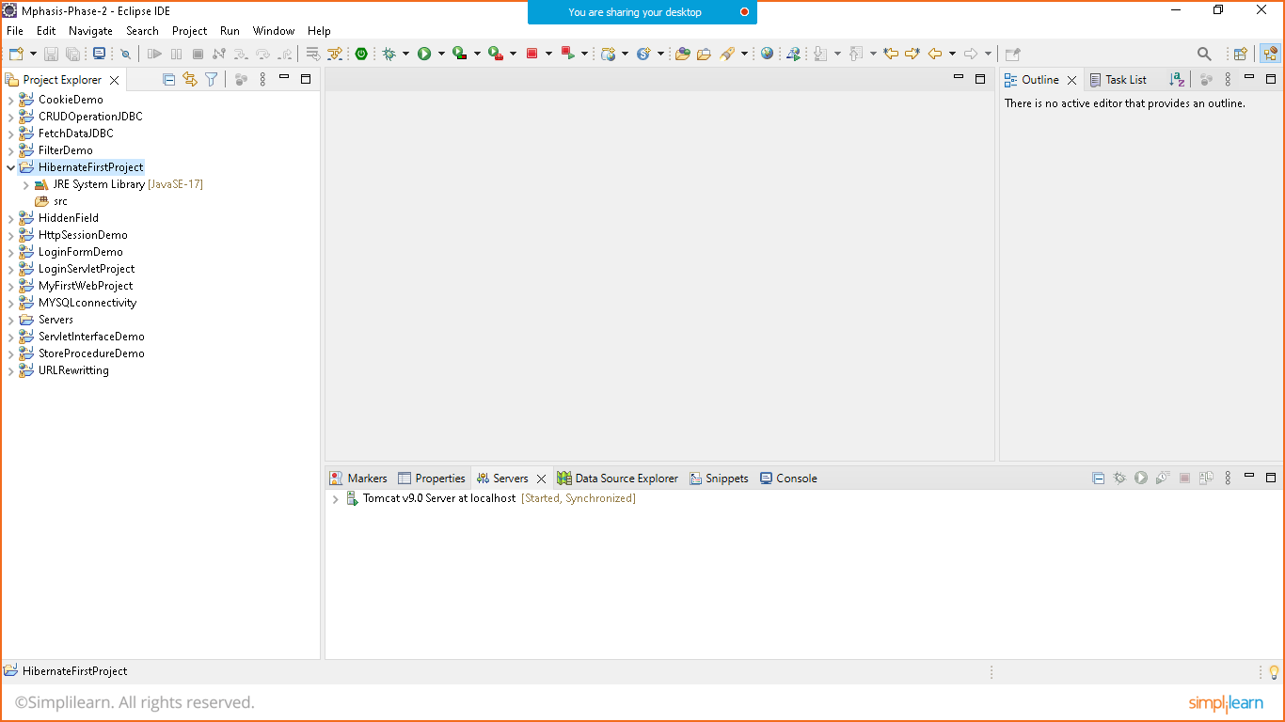

STEP 6: ADD HIBERNATE AND MYSQLCONNECTOR LIBRARY FILES

* Right click on project>buildpath>configure buildpath>select library tab> click on classpath> add exeternal jar button> select your folder and add alljar files you have downloaded> aplly> apply and close.

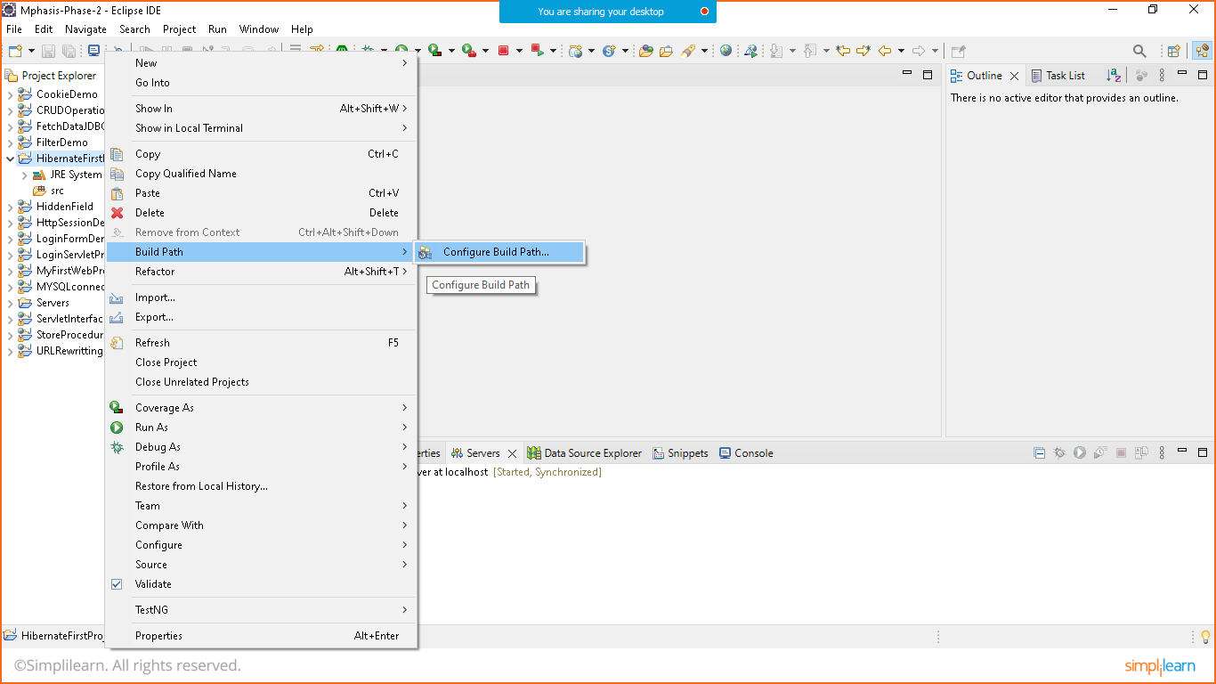

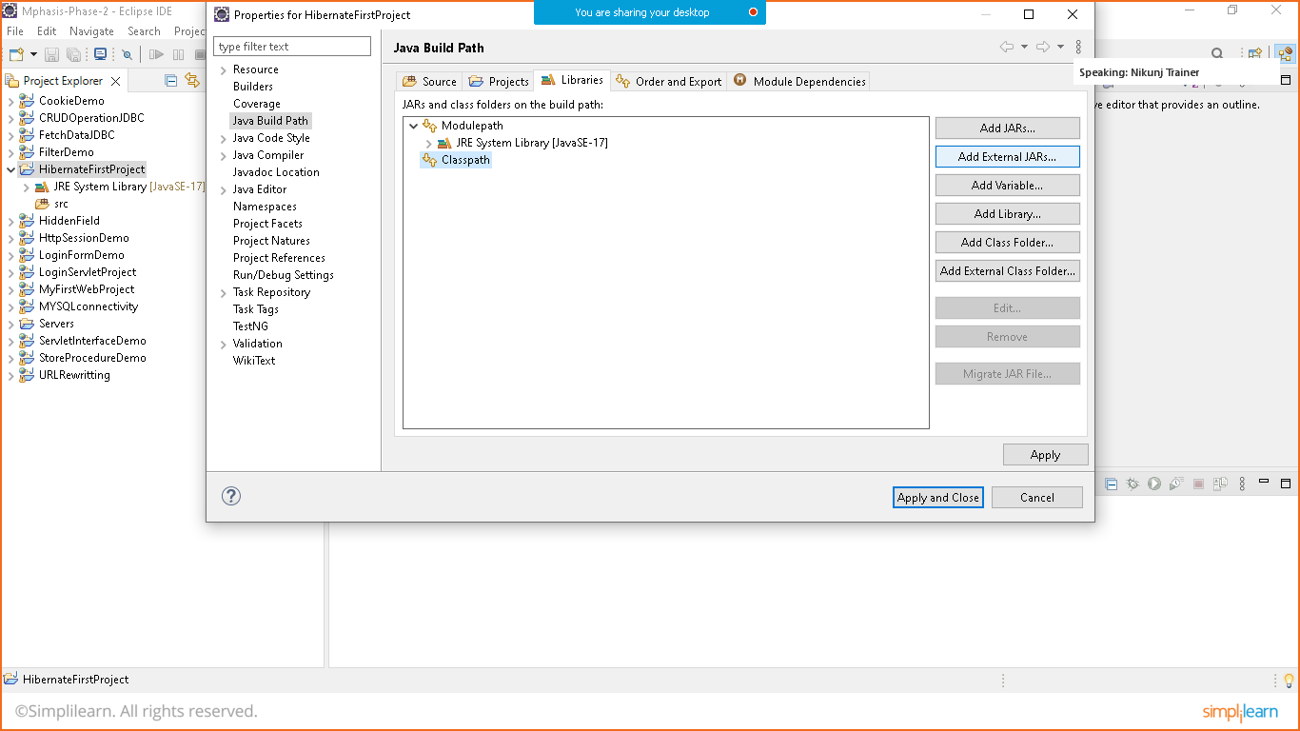

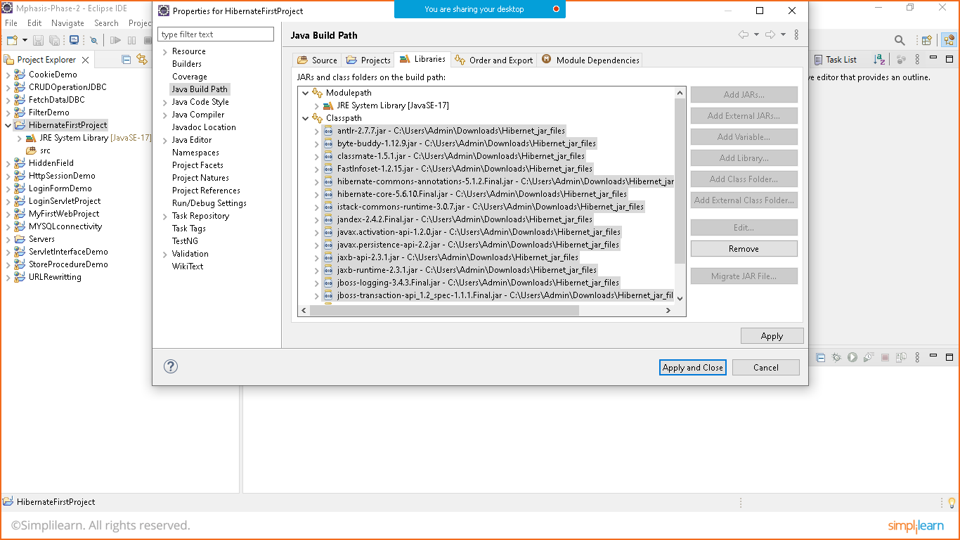

STEP 7: create POJO (Bean Class)

Student.class

**package** com.simplilearn.demo;

**public** **class** Student {

**private** **int** id;

**private** String name;

**private** String email;

**private** String password;

**public** **int** getId() {

**return** id;

}

**public** **void** setId(**int** id) {

**this**.id = id;

}

**public** String getName() {

**return** name;

}

**public** **void** setName(String name) {

**this**.name = name;

}

**public** String getEmail() {

**return** email;

}

**public** **void** setEmail(String email) {

**this**.email = email;

}

**public** String getPassword() {

**return** password;

}

**public** **void** setPassword(String password) {

**this**.password = password;

}

}

STEP 8: create configuration File

Goto> src> right click>new >other>xml>select xml file> give name (hibernate.cfg.xml)

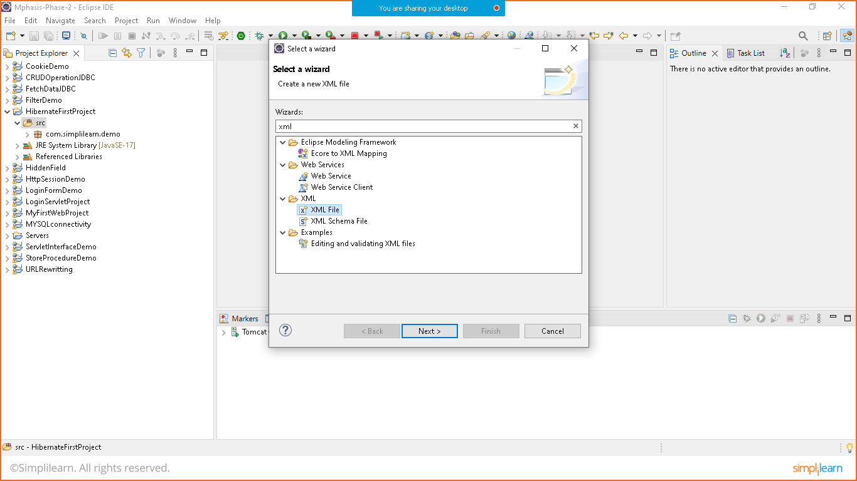

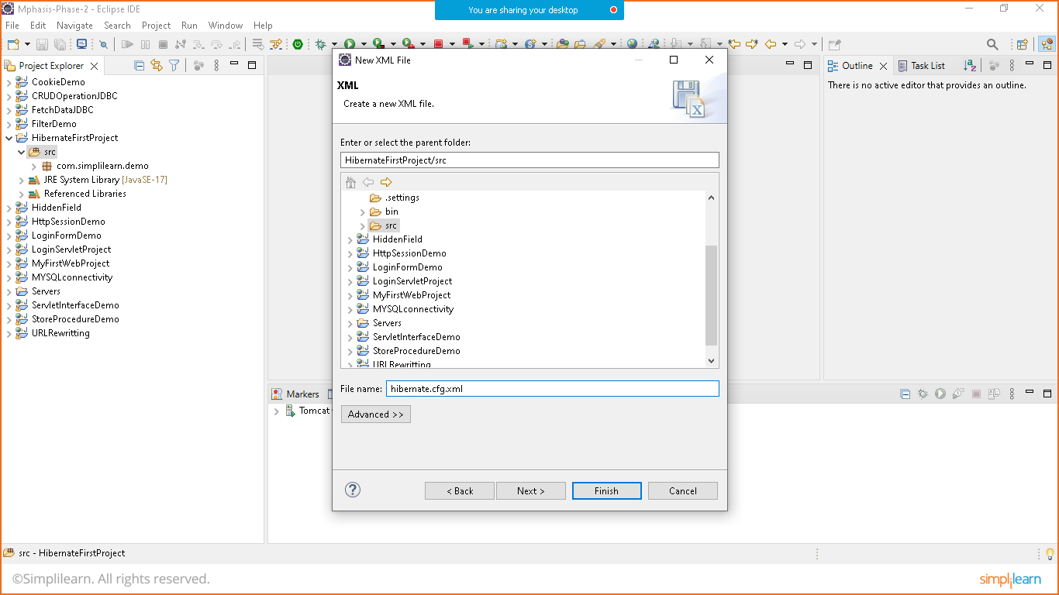

* Once the xml file is created the you have to add dtd(data type definition configuration) that you can get it online as well as you can get it from jar file
* To get configuration
  + Expand libraries>open hibernate.core>expand orm.hibernate>scroll downwhere yopu will see two files with .dtd and .xsd extension for mapping and configuratioin

(you can copy config from mapping dtd and configuration config from configuration dtd)

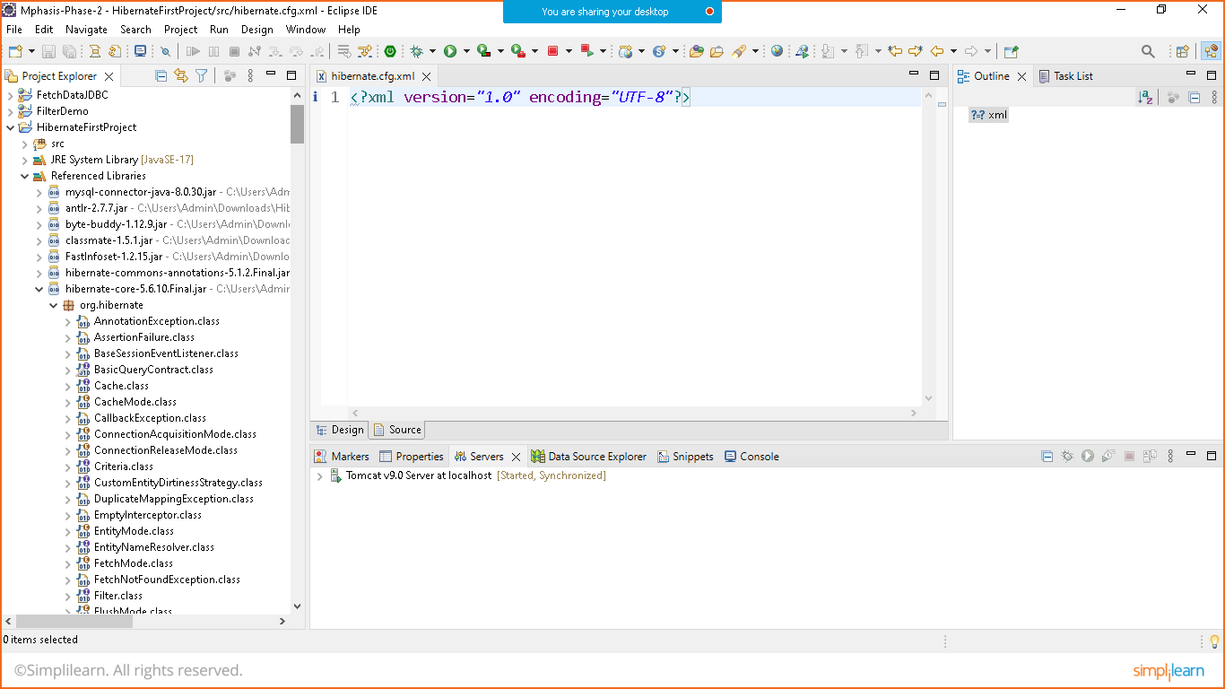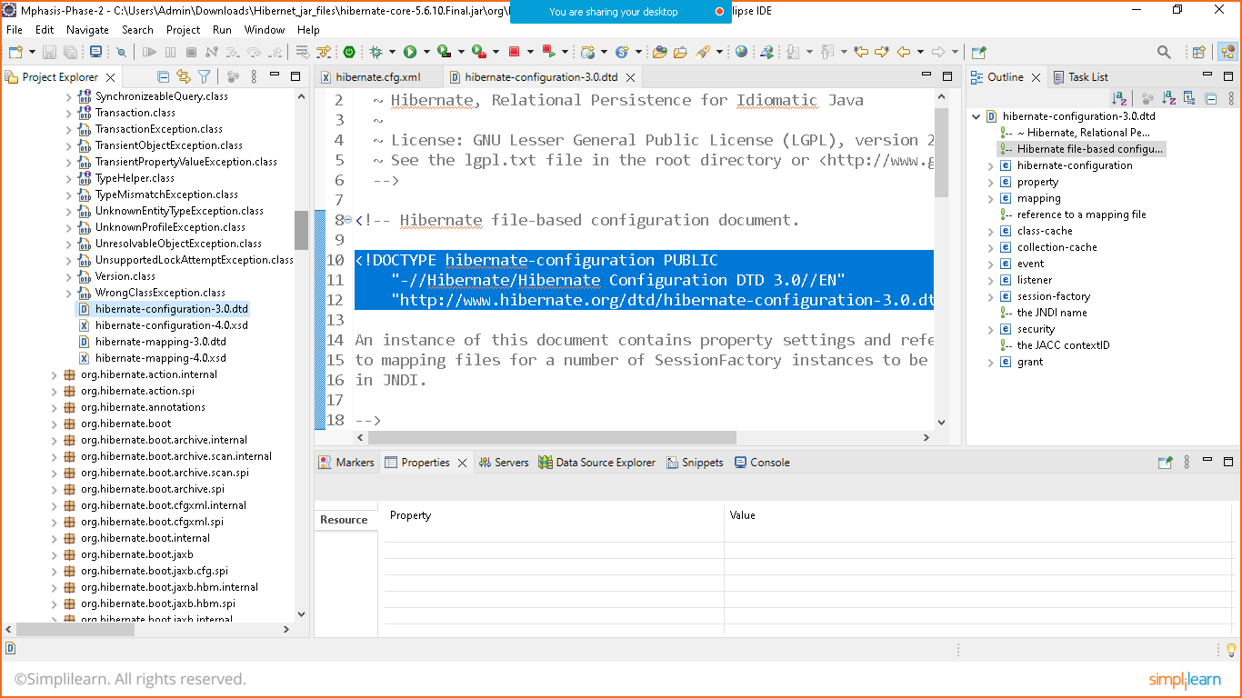

Hibernate.cfg.xml

----------------------

<?xml version=*"1.0"* encoding=*"UTF-8"*?>

<!DOCTYPE hibernate-configuration PUBLIC

"-//Hibernate/Hibernate Configuration DTD 3.0//EN"

"http://www.hibernate.org/dtd/hibernate-configuration-3.0.dtd">

<hibernate-configuration>

<session-factory>

<property name=*"connection.driver.class"*>com.mysql.cj.jdbc.Driver</property>

<property name=*"connection.url"*>jdbc:mysql://localhost:3306/student</property>

<property name=*"connection.username"*>root</property>

<property name=*"connection.password"*>Nikunj@123</property>

<property name=*"hbm2ddl.auto"*>update</property>

<mapping resource=*"student.hbm.xml"*/>

</session-factory>

</hibernate-configuration>

STEP 9: create mapping File

Goto> src> right click>new >other>xml>select xml file> give name (student.hbm.xml)

Goto the same library folder and copy the mapping as mentioned below(hibernate-mapping.dtd) 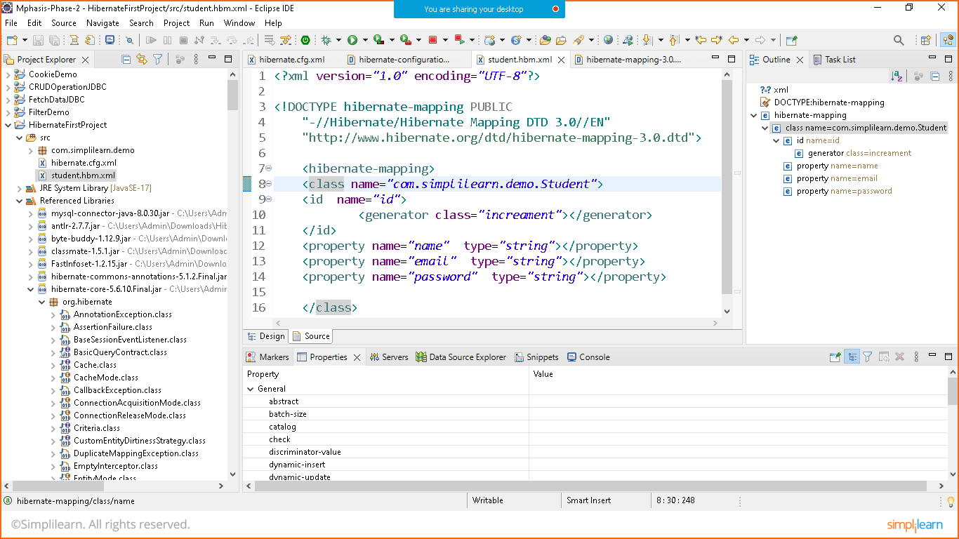

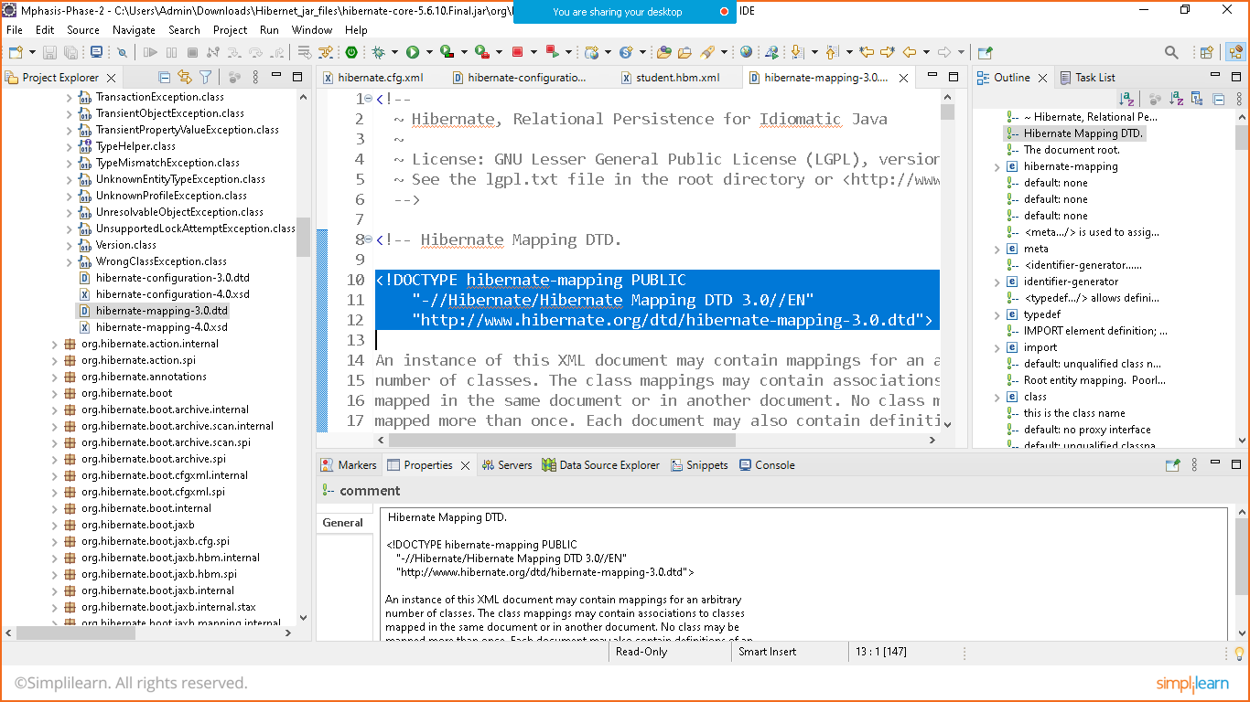

student.hbm.xml

<?xml version=*"1.0"* encoding=*"UTF-8"*?>

<!DOCTYPE hibernate-mapping PUBLIC

"-//Hibernate/Hibernate Mapping DTD 3.0//EN"

"http://www.hibernate.org/dtd/hibernate-mapping-3.0.dtd">

<hibernate-mapping>

<class name=*"com.simplilearn.demo.Student"*>

<id name=*"id"*>

<generator class=*"increment"*></generator>

</id>

<property name=*"name"* type=*"string"*></property>

<property name=*"email"* type=*"string"*></property>

<property name=*"password"* type=*"string"*></property>

</class>

</hibernate-mapping>

STEP 10: Run The Program

Prepare JAVA class Main and Main Method to run the program

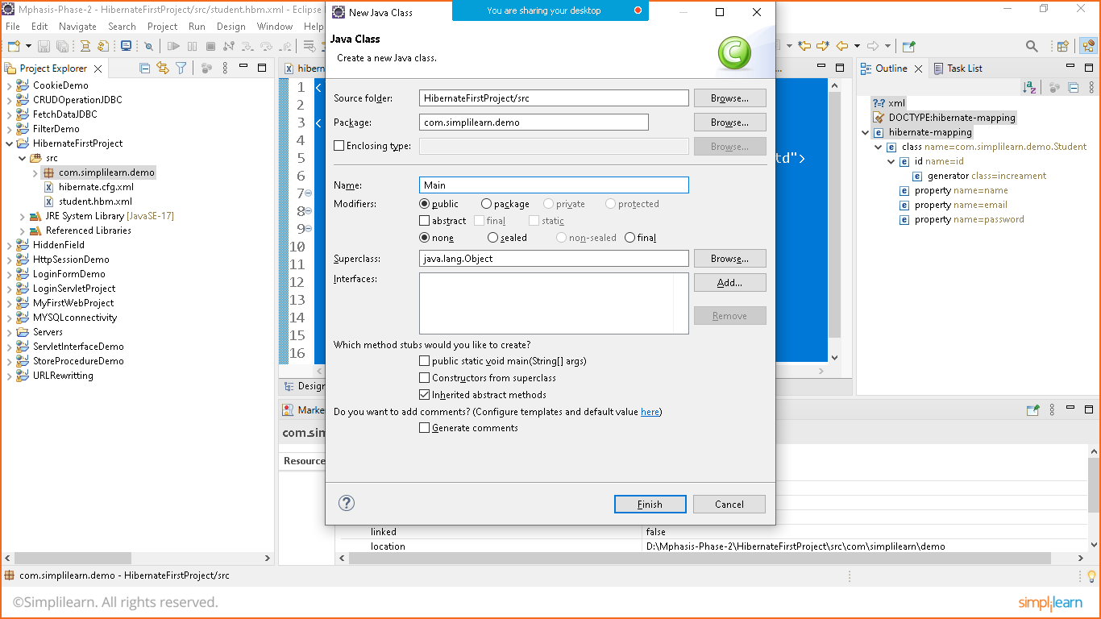

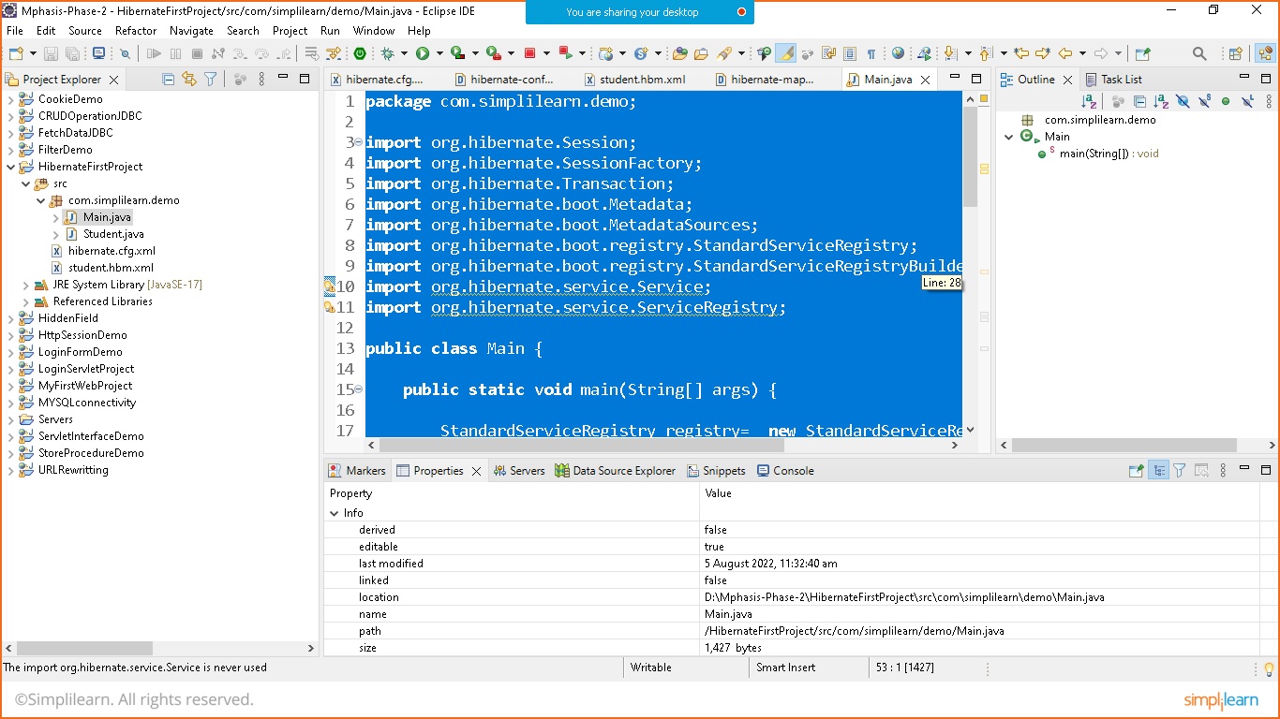

Main.class

**package** com.simplilearn.demo;

**import** org.hibernate.Session;

**import** org.hibernate.SessionFactory;

**import** org.hibernate.Transaction;

**import** org.hibernate.boot.Metadata;

**import** org.hibernate.boot.MetadataSources;

**import** org.hibernate.boot.registry.StandardServiceRegistry;

**import** org.hibernate.boot.registry.StandardServiceRegistryBuilder;

**import** org.hibernate.service.Service;

**import** org.hibernate.service.ServiceRegistry;

**public** **class** Main {

**public** **static** **void** main(String[] args) {

StandardServiceRegistry registry= **new** StandardServiceRegistryBuilder()

.configure("hibernate.cfg.xml").build();

Metadata metadata= **new** MetadataSources(registry).getMetadataBuilder().build();

//connection pool

SessionFactory factory= metadata.getSessionFactoryBuilder().build();

//let's take database connection to do transaction

//prepare one database in mysql with name Student before executing below command

Session session= factory.openSession();

Student s1= **new** Student();

s1.setName("Nikunj");

s1.setEmail("nikunj@gamil.com");

s1.setPassword("Nikunj@123");

Transaction tx=session.beginTransaction();

session.save(s1);

tx.commit();

//automatically table created in db and data inserted in the same

session.close();

factory.close();

System.***out***.println("Data Inserted Successfully");

}

}

Right click on project and run as java Application

